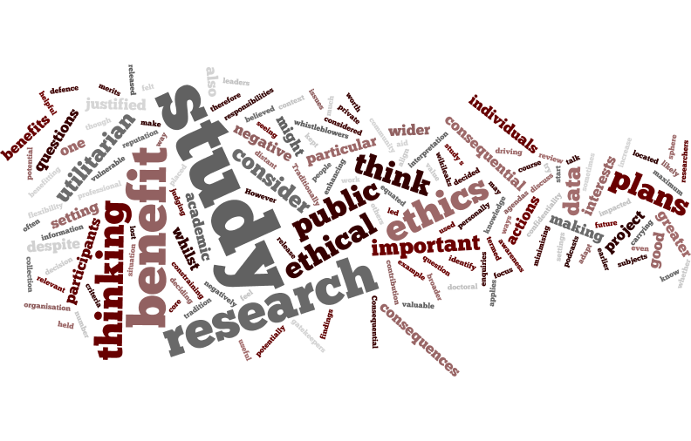
What? Come and develop a personal and practical approach to ethical research!
When? 10th June 2019 between 10.00am – 1.00pm
Where? Barbara Strang Teaching Centre, B.32
Why?
This workshop will support you in reviewing what YOU think makes worthwhile research and how you can work towards meeting these aspirations whilst attending to obligations of you as a researcher. This will involve clarifying what YOU value and thinking about how to put these values into practice as you develop a research project which involves human participants, including the challenges and opportunities of being a practitioner researcher. Dr Alison Fox, from the Open University, will start by leading you through the four-dimensional C.E.R.D. framework to support you in confident ethical appraisal and decision-making. The workshop will consider the whole research journey to support you in: gaining ethical approval, identifying what is important to consider when conducting your study and examining issues associated with reporting your findings, including how being transparent about your ethical decision-making can be part of claiming the quality of your research.

If you can… It would be great if you could bring concrete examples of projects you have completed, are currently running or have ideas for. There will also be examples provided.

Image with thanks to Alex Fox

