NU-KESS
(Newcastle University Knowledge Exchange Seminar Series)

Can your research inform local policy?
The Newcastle University Knowledge Exchange Seminar Series (NU-KESS) aims to promote evidence led policy making and provides a forum for researchers to present their research findings in a straightforward format on issues that are relevant to local decision makers.
NU-KESS is delivered in partnership with Newcastle City Council, Gateshead Council, Northumberland County Council, North Tyneside Council and South Tyneside Council, North East Local Enterprise Partnership (NELEP) and the North East England Chamber of Commerce (NEECC).
Would you like to present your research to local decision makers?
What’s involved?

- Identify which of the ‘Hot Topics’ you will address and submit a 150 word abstract.
- Attend a 1 hour training workshop prior to the seminar to develop your ideas.
- Prepare and deliver a 30 minute presentation (up to a maximum of 20 slides) to an audience of local decision makers.
- Prepare a written 4-5 page policy briefing for dissemination at the event.
Why should I take part?
Benefits to participants include:
- Increased connections and engagement with policy makers.
- Enhanced impact of your research.
- Development of new ideas leading to further research.
- Connecting with other researchers; working on locally relevant topics.

The call for application submissions for the 2019/20 programme is now open and closes at midnight on Wednesday 31st July.
The call is open to all academics at Newcastle University and we are looking for presentations that relate to the ‘hot topics’ policy makers have identified as a high priority for the local area.

Submissions as a team/group are welcome i.e. may include academics from other institutions; however the lead academic must be from Newcastle University.
If you are interested in taking part please read the guidance document and complete the online form.
Submissions and queries should be sent to:
nu.policyacademy@ncl.ac.uk

 | 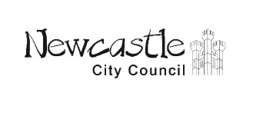 | 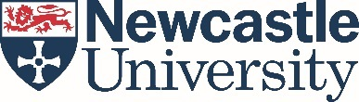 | 
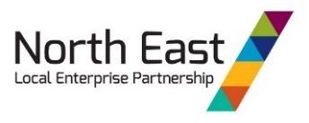 | 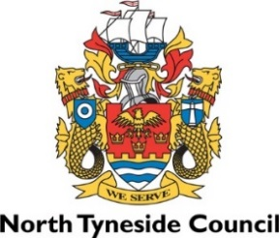 |  | 