Understanding the WebPA Algorithm
WebPA is a tool to used to provide a peer-assessment element to group activities.
This document shows how WebPA uses student feedback to provide individual marks and guides you through the impact of the WebPA weighting.
For this example we’ll consider a scenario of a group of 6 students who have worked together to produce a group project. You mark this project and give an overall score of 60%.
Without any in-group assessment the picture of marks awarded for the 6 students would be:
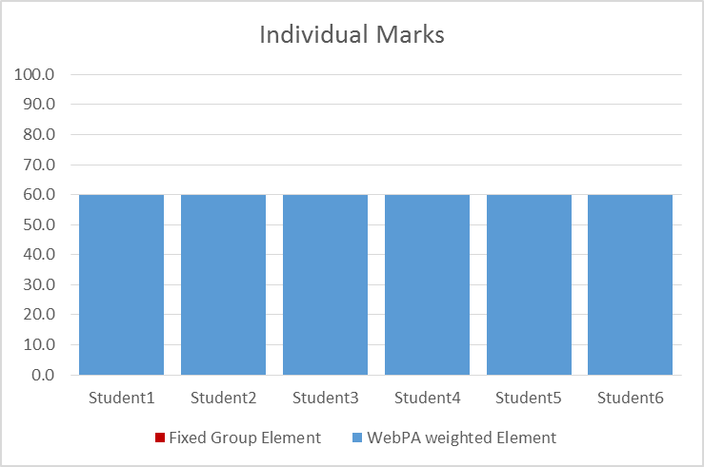

This will not reflect the fact that the six students will have put different amount of effort into the groupwork.

WebPA Scores are based on Relative contributions
WebPA uses the assessment form questions you create to work out the relative contributions of group members.
It’s easiest to think of this as a pie chart, if everybody’s contribution was equal, the pie chart would look like this:
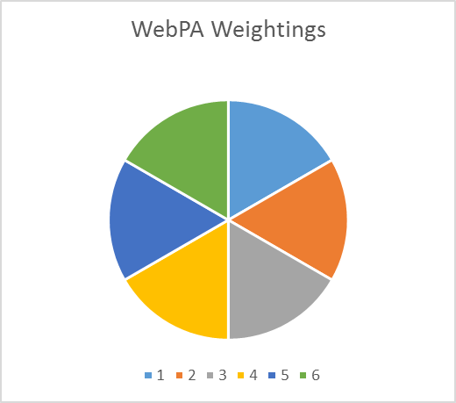

WebPA gives each student a WebPA score reflecting their contribution. A student with an average contribution gets a WebPA Score of 1.
But, if student 1 was the group star and student 6 barely did anything the pie chart would look different:
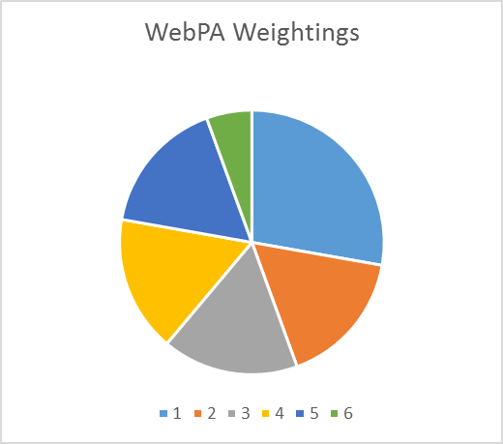
In this Pie Chart Student 1’s WebPA score is 1.67, students 2-5 have a score of 1 and student 6 has a low score of 0.33.
WebPA uses this contribution graph to work out individual scores – these individual scores are based on the student’s contribution and the group score.
We’d expect for the scenario above for student 1 to get a mark higher than the group score, for student 6 to receive a mark lower than the group score, and for those in the middle to get a score close to the tutor awarded mark for the overall group project.
Plotted on a graph this would look something like the following.
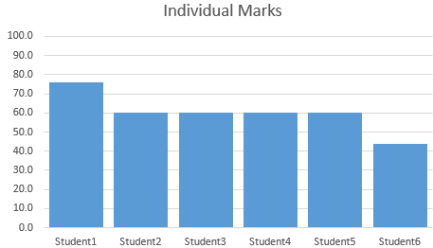

WebPA Weighting
As a tutor you have input into how much influence the WebPA scores have on the marks awarded to individual team member – you do this by choosing a WebPA weighting when you generate a mark sheet.
It is easiest to look at how the WebPA Weighting works by looking at two examples.
If you set a WebPA weighting of 100% then WebPA works out individual scores by multiplying each student’s WebPA weighting by the group score.
Student1’s score becomes 1.67 x 60 = 100.2 (which WebPA rounds down to 100).
Students2-5 score 1 X 60 = 60
Student6’s score becomes 0.33 X 60 = 19.8

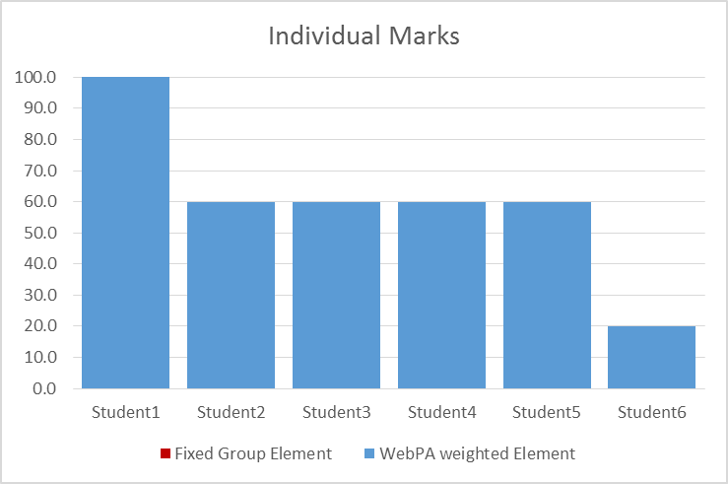
You’ll see with this weighting that student 1 gets a really high mark and student 6 fails the project.
It the WebPA weighting is set lower than 100% WebPA gives each student a fixed proportion of the tutor mark and adds to this a proportion of the score multiplied by the WebPA weighting.
If the WebPA weighting is 50% then students’ scores become (50% X Group Score) + (50% X Group Score X WebPA score)
Student1 score is then (50% X 60) + (50% x1.67 X 60) = 80
Student2-5 score is (50% x 60) + (50% x 1 x 60) = 60
Student6 score is (50% X 60) + (50% X 0.33 X 60) = 40
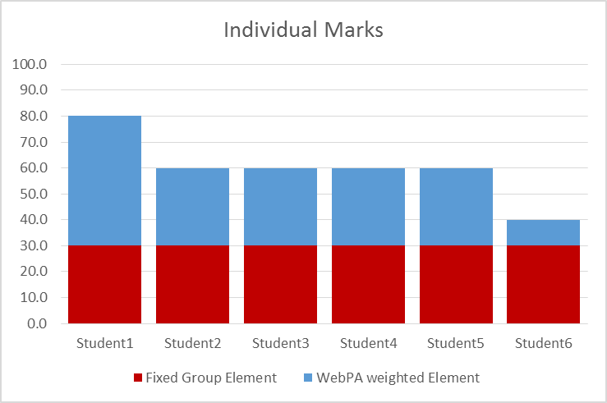
Because students receive a fixed element, you can see that lower WebPA weightings produce less variance in the scores. (The range of scores here has decreased from 80 to 40.)
If we use a lower WebPA weighting of 20% then all students get 80% of the group mark + a WebPA adjusted factor. The range decreases further to 16 (min = 52 max = 68)
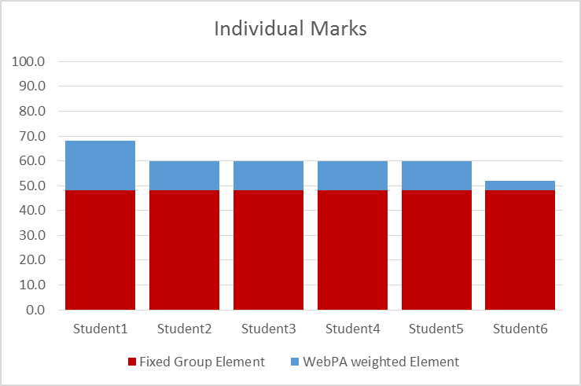

Note: This example was based on the student scoring grid below:
 | Student1 | Student2 | Student3 | Student4 | Student5 | Student6
Student1 | 5 | 3 | 3 | 3 | 3 | 1
Student2 | 5 | 3 | 3 | 3 | 3 | 1
Student3 | 5 | 3 | 3 | 3 | 3 | 1
Student4 | 5 | 3 | 3 | 3 | 3 | 1
Student5 | 5 | 3 | 3 | 3 | 3 | 1
Student6 | 5 | 3 | 3 | 3 | 3 | 1

