How does WebPA work out the student contributions?
When you set up a WebPA assessment form you specify a number of criteria that students complete. Typically each group member assesses their own work and the work of their peers.
The table below shows the scores collected by each student when asked to score their peers for a specific criteria (on a 1-5 scale). The rows labels show the students giving the score, and the columns are the students receiving the score. You can see from this that student4 had given student 1 a score of 3 and student6 a score of 1. Student1’s column shows that he/she is the top performing student and the column for student6 shows that this is the least well appraised student.
 | Student1 | Student2 | Student3 | Student4 | Student5 | Student6
Student1 | 4 | 3 | 3 | 3 | 3 | 1
Student2 | 4 | 3 | 3 | 3 | 3 | 1
Student3 | 5 | 3 | 3 | 3 | 3 | 1
Student4 | 3 | 2 | 2 | 2 | 2 | 1
Student5 | 4 | 3 | 3 | 3 | 3 | 1
Student6 | 3 | 2 | 2 | 2 | 2 | 2

Normalising Scores
Students will vary in how generous they are when applying the marking criteria so the first thing WebPA does with scores is to normalise them.
Student4 has given a total of 12 marks while Student3 has given a total of 18 marks. WebPA normalises these scores, by working out what the scores would be if each student had 6 marks to divide up between themselves and their peers.
Student4 gave out a total of 12 marks and awarded a mark of 3 to student 1.
The normalised mark that student1 receives from student4 is
(Mark given by student4/total of marks given by student4) * number of students
i.e. 3/12 X 6 = 1.5

 | Student1 | Student2 | Student3 | Student4 | Student5 | Student6
Student1 | 1.41 | 1.06 | 1.06 | 1.06 | 1.06 | 0.35
Student2 | 1.41 | 1.06 | 1.06 | 1.06 | 1.06 | 0.35
Student3 | 1.67 | 1.00 | 1.00 | 1.00 | 1.00 | 0.33
Student4 | 1.50 | 1.00 | 1.00 | 1.00 | 1.00 | 0.50
Student5 | 1.41 | 1.06 | 1.06 | 1.06 | 1.06 | 0.35
Student6 | 1.38 | 0.92 | 0.92 | 0.92 | 0.92 | 0.92

WebPa Score Derived from the Average
Once scores are normalised in this way, they can be averaged. Student1’s WebPA score becomes the average of the first column (1.41+1.41+1.67+1.50+1.41+1.38)/6 = 1.46
 | Student1 | Student2 | Student3 | Student4 | Student5 | Student6
Student1 | 1.41 | 1.06 | 1.06 | 1.06 | 1.06 | 0.35
Student2 | 1.41 | 1.06 | 1.06 | 1.06 | 1.06 | 0.35
Student3 | 1.67 | 1.00 | 1.00 | 1.00 | 1.00 | 0.33
Student4 | 1.50 | 1.00 | 1.00 | 1.00 | 1.00 | 0.50
Student5 | 1.41 | 1.06 | 1.06 | 1.06 | 1.06 | 0.35
Student6 | 1.38 | 0.92 | 0.92 | 0.92 | 0.92 | 0.92
WebPA score | 1.46 | 1.02 | 1.02 | 1.02 | 1.02 | 0.47

If this group has a group mark of 60 and we allocate a 50% WebPA weighting the marks will vary as follows:

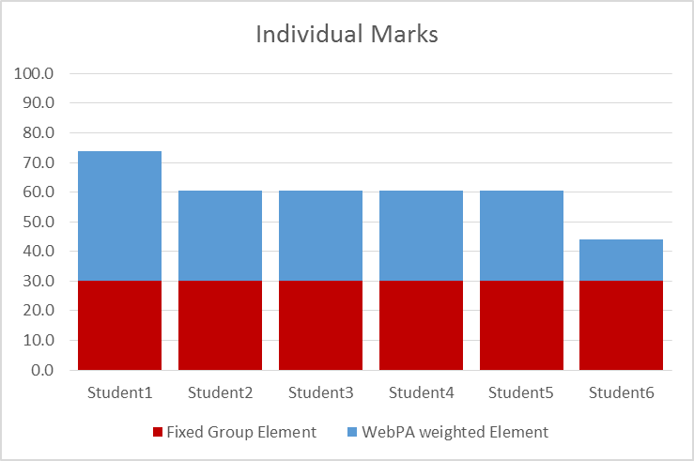

Some Implications of this Scoring Algorithm
- WebPA scores should always be used with a group mark
The emphasis of WebPA’s algorithm is “what were the relative contributions of students to the group task”. It relies upon interaction with a group mark to give an indication of effort. A group taking a minimal approach, who rate each other equally will have the same WebPA scores as a dedicated team producing an excellent result.

- Score inflation if one member underperforms
If a group member drops out of the group they will (rightly) get a low score from their peers. But a consequence of this is that other group members scores will be higher. Our example shows a team of 6, if one member does nothing the available effort score (6) is in effect divided out between the remaining 5 members. Arguably the remaining group members will have had to work harder to compensate for this, but some moderation may be needed.

