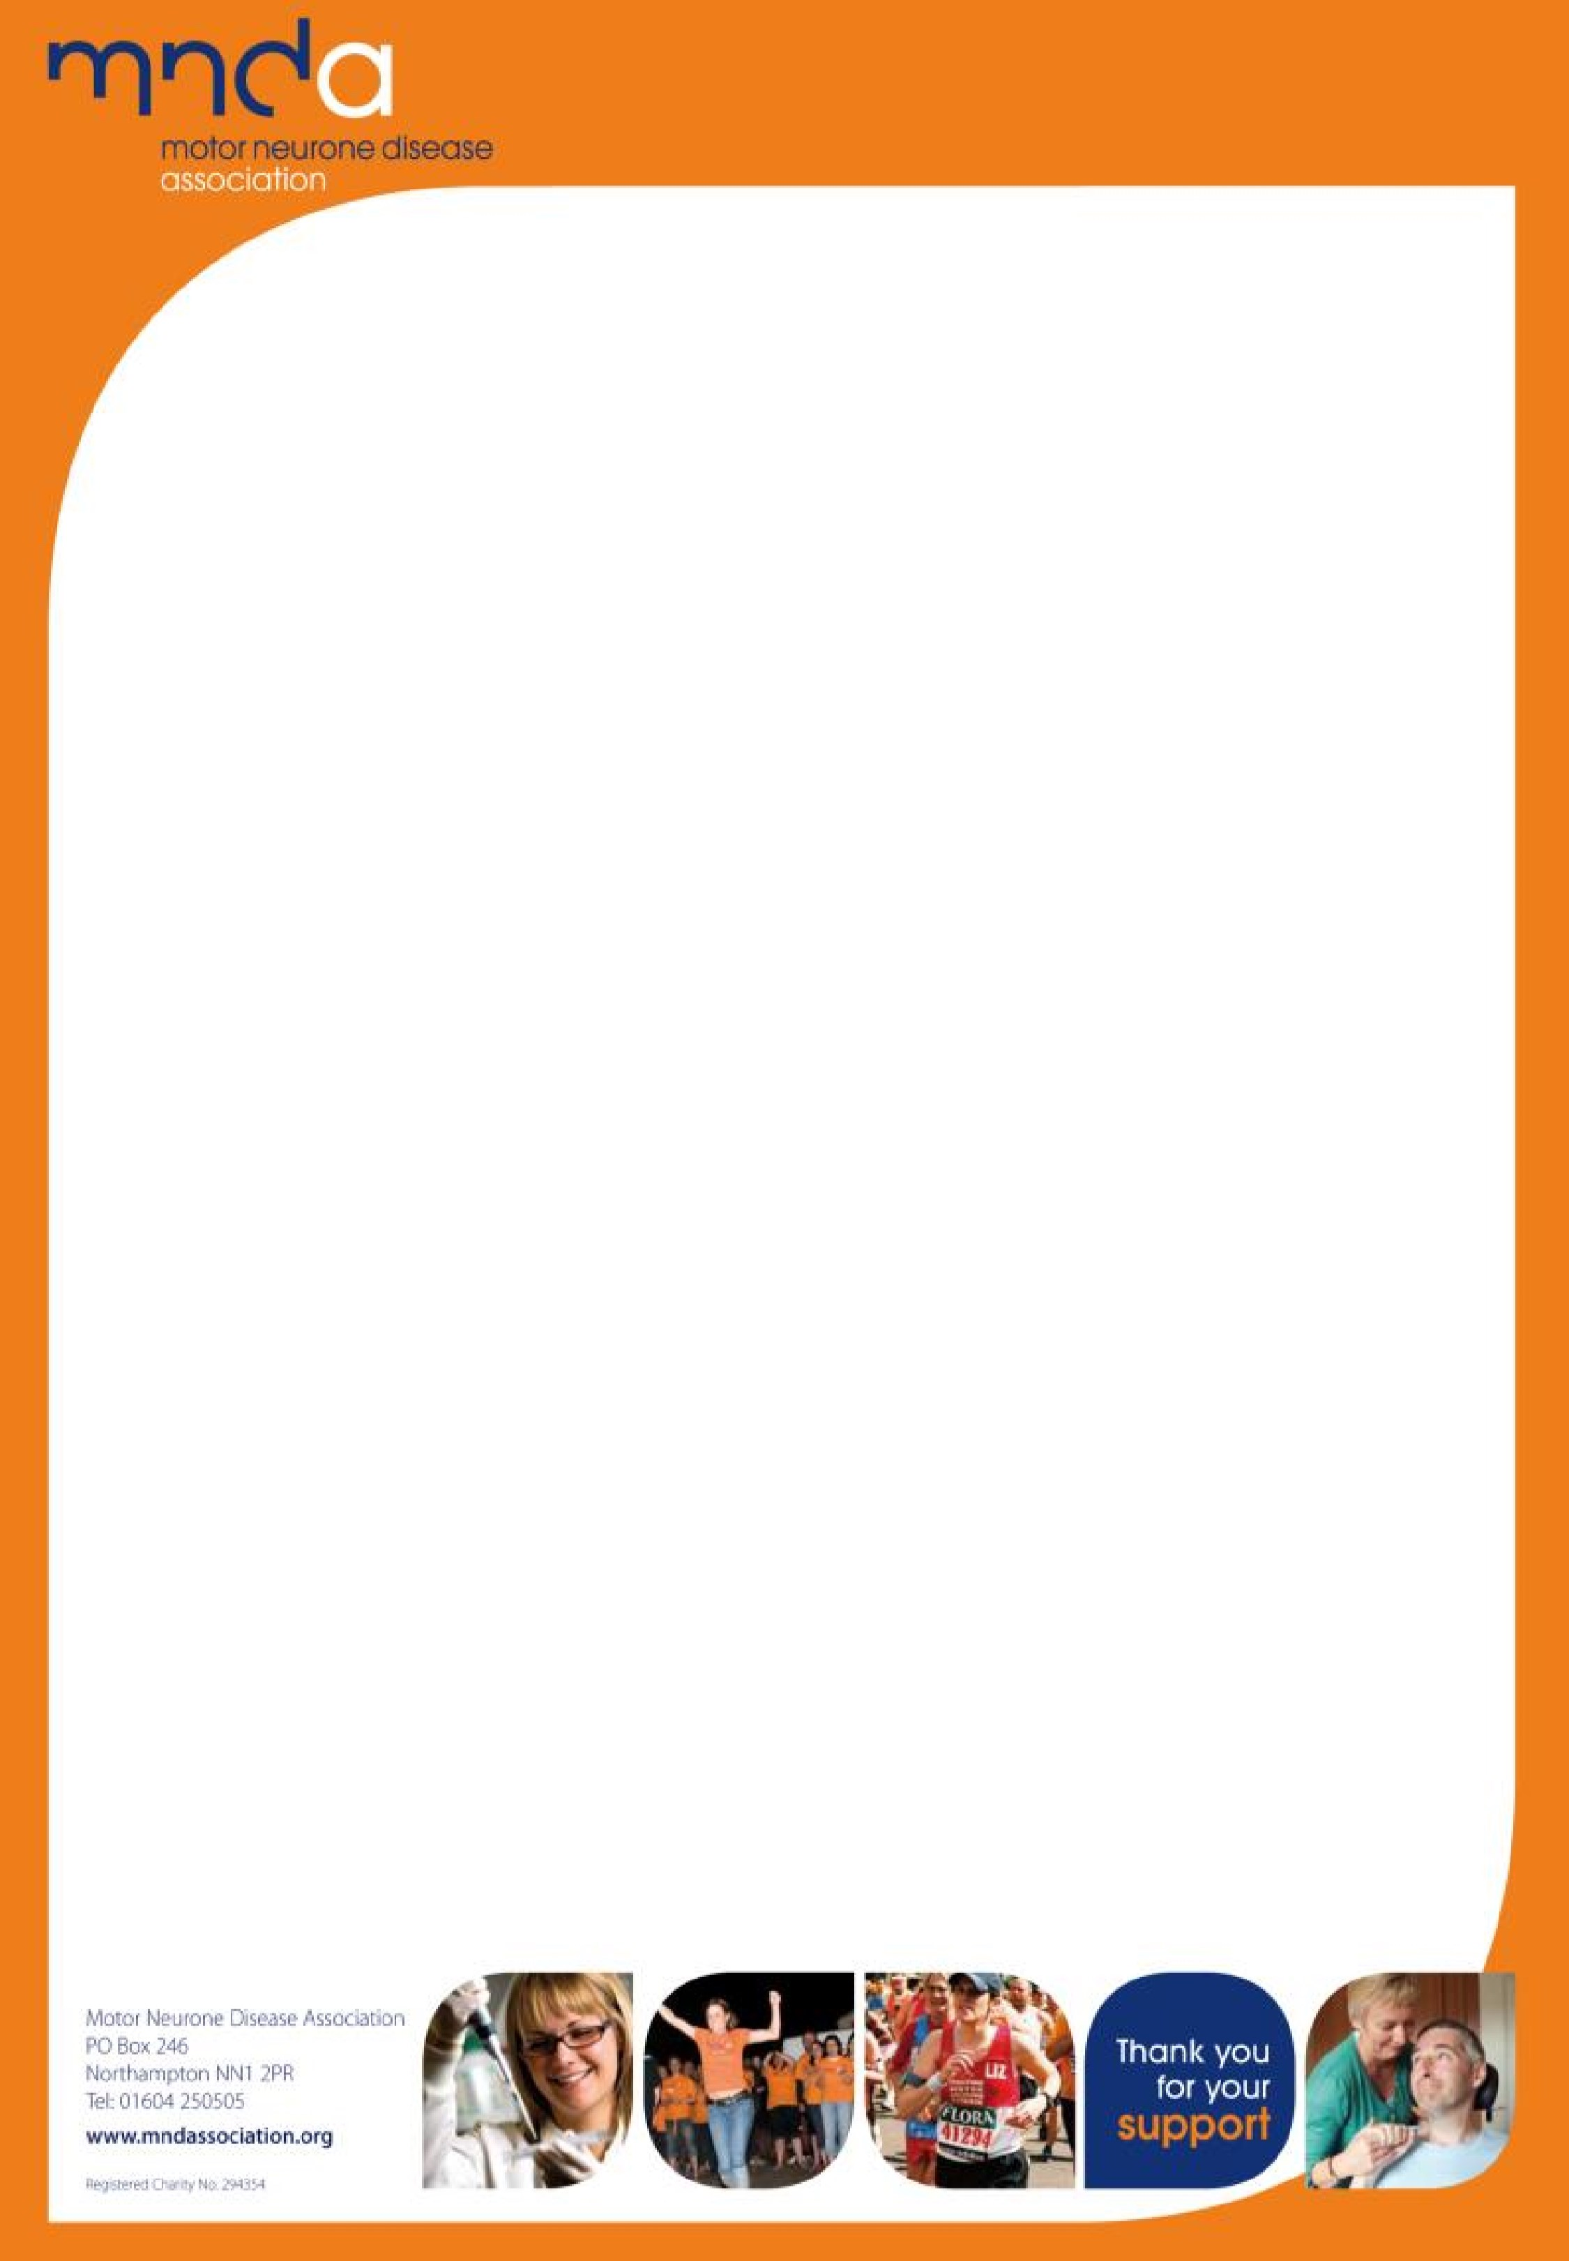










To register your interest and receive further information e-mail
Marian.dent@ncl.ac.uk

Approaches to Symptom Management
Practical Implementation of the NICE Guidelines
-
Motor Neurone
Disease Education
Day
Who should attend?
Health & Social Care Professionals
Content:
An education event to help you
Understand the practical implications of the NICE Guidelines on MND and how
these will influence practice and management of symptoms, providing the best
possible care and support for those affected by MND.
Explore models of intervention and symptom management in the community.
Sessions to empower and upskill professionals on aspects of symptom
management
Working as an MDT. How do we co-ordinate care well?

Cost:
£30
Date:
Wednesday
13th
December 2017
Time:
Registration
8:30am
9:00am – 16:45

Location:
The Work Place, Newton Aycliffe Business Park, Newton Aycliff, DL5 6AH
Save the Date!
Sponsor:

