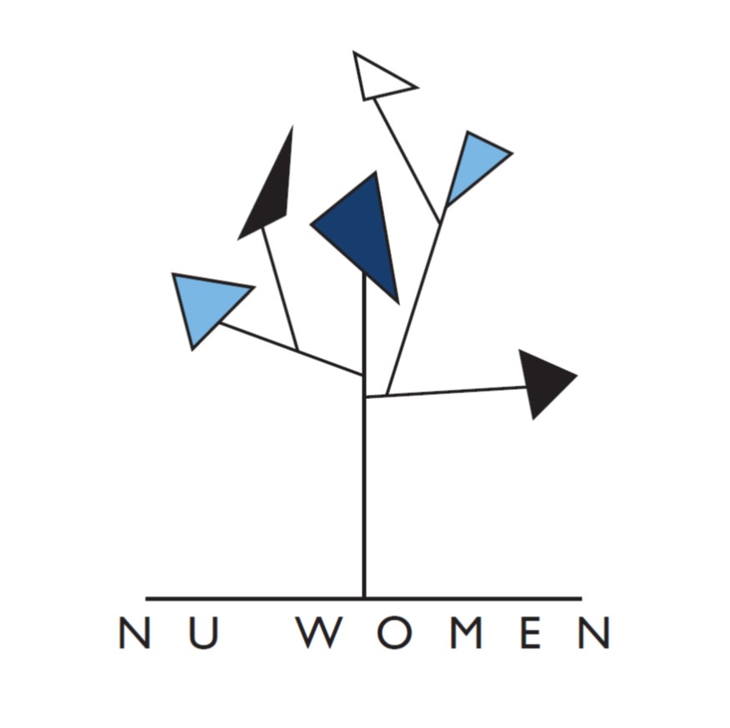

NU Women Annual Report

Overview

This report provides an overview of all NU Women events and initiatives, and a summary of responses to the NU Women Annual Survey 2020/21. The report opens with an executive summary, followed by a short summary of challenges and opportunities. There are three appendices: a summary of 2020/21 events; an outline of other NU Women initiatives, and the results of the annual survey.

Executive Summary

- NU Women is open to all women staff and PGRs, as well as male and non-binary allies, at Newcastle University. Some events are women-only.
- Members often state (via the survey, in the chat at Zoom events, via email) that they value highly their connection to a community through NU Women.
- Members find the work of the network particularly valuable during the last year. The move to record events has made the work of NU Women more accessible to a wider audience. We will work to preserve this accessibility in future through a blended programme.
- Our mailing list is how we communicate most regularly with members. There are currently over 1100 subscribers.
- Online communication and engagement with members (recorded events, newsletter, Twitter, and blog) are especially valued by members.
- NU Women ran 10 online events with a range of external and internal speakers, in addition to its other initiatives (film, newsletter, zine, writing groups, Teams site, one-to-one support for individual members, blog, Twitter feed, charity drive).
- The newsletter was upgraded in January 2021 and is now circulated via the e-marketing tool MailChimp.
- A representative from NU Women sits on the following University committee: Changing the Culture Working Group, Rewards Forum, EDI Network Leads Committee, HASS EDI Committee, Athena Swan Institutional SAT, FMS Equality Project Strategic Board, UEC: PGR & EDI Working Group. Through these committees,NU Women provides feedback on University policies, processes and practices.
- Finally, NU Women had four student interns this year through JobsOC: Maia Almeida-Amir, Abigail Hockaday, Alex Joyce and Caroline Rae. All of the NU Women events and initiatives happened because of their expertise, labour, care, and commitment. I thank them wholeheartedly on behalf of NU Women members.

Challenges and Opportunities

NU Women has been working closely with its sister EDI networks - NU Parents, NU Carers, DIG, REN, and Rainbow+ - over the past 18 months in developing plans for collaborative EDI work, which speaks to the intersectional agenda of the revised Athena Swan documentation. An example of this collaboration is NU Women and Rainbow+ leading on the Intersectionality: Multitudes Project (supported by the EDI Fund), with a range of outputs reaching maturity this coming year (including a peer-reviewed publication on the emotional labour of EDI work). For more on the Intersectionality project, see: https://www.multitudes.blog.

This past year has seen a substantial change in the Steering Group: several individuals have left the institution, an experienced Deputy Chair became Chair of NU Parents, and other members are stepping down after over six years of service. Recognition for the labour of sitting on the Steering Group needs to be formalised across the institution (academic colleagues: workload and promotions; PS colleagues: complexities of ‘volunteer’ labour). The University needs a strong and diverse Steering Group constituency for the EDI networks in order to support members across the institution. There are currently barriers to some participating in the governance of EDI networks, and the labour rests upon the shoulders of a few.

As NU Women goes from strength to strength, as member numbers grow, and as the remit within the institution develops, there are challenges in terms of how to meet the needs for all members. EDI work is visible at Newcastle, but what is not always recognised is the labour behind this work. This is a significant challenge for the institution in the coming years in terms of achieving its equality and diversity goals.

Dr Stacy Gillis
Chair, NU Women
July 2021

Appendix 1: Events

Number of attendees refers to those who attended the Zoom sessions: many members indicated that they watched the recording at a later date.

Event Name | Event Date | Attendees
Reimagine Research Culture Workshop | 23 June 2020 | 14
Career Conversations: Five Things | 21 and 30 July | 23
Career Conversations: There’s Something I’d like to Ask You... | One-to-one interviews between 16 July and 14 August 2021 | 4
Carly Jones, MBE - “Autism in Women” | 14 October 2020 | 85
Alison Andrew (Institute for Fiscal Studies) - “The Gendered Division of Paid and Domestic Work Under Lockdown” (Annual Lecture) | 11 November 2020 | 101
Ovarian Cancer Awareness (Ovacome Charity and Dr Ruth Grigg, Newcastle University) | 26 November 2020 | 9
Dr Sarah Burton (City University) - ‘“The kind of thing you see on Morse’: Dark Academia, Gender, and Aesthetic Practices of the Intellectual” | 12 February 2021 | 175
Dr Emily Yarrow (University of Portsmouth) - “An Unequal Opportunity? Female Academics’ Experiences of Research Evaluation in the UK” | 26 February 2021 | 56
Professor Muzlifah Haniffa (Newcastle University) - “Diversity, Unconscious Bias and Research Culture” | 2 March 2021 | 77
The Girls’ Network Volunteering Event | 13 May 2021 | 7
Dr Barbara Read (University of Glasgow) - “Casualised Academic Staff and the Threat of ‘failure’: Power, :Legitimacy and (Im)Permanence” | 19 May 2021 | 38
Writing Groups | Weekly | 41

Appendix 2: Initiatives

Social Media
The blog contains new material as well acting as an archive for events. Each of the latter has a recording of the event (where possible) and a written summary of the key points. The blog is available here: https://blogs.ncl.ac.uk/nuwomen/. NU Women also tweets regularly at @https://twitter.com/nu_women (with nearly 1800 followers).

Zine
For Women’s History Month 2021, NU Women put out a call for creative responses to working conditions during the Covid pandemic to be included in a zine entitled The Lockdown Shift. The zine will be launched in September 2021 with 1,000 physical copies to be distributed across Newcastle University campus and a simultaneous digital publication. The full impact of this project will be felt in next year’s report; however, survey results include members citing it as one of the most valuable activities organised by NU Women this year.

Charity Collection
NU Women continued to run its charity clothing drive in 2020, collecting over 400 pairs of glasses for Vision Aid Overseas. The success of this drive follows on from the 2019 collection where NU Women amassed over 2500 items of winter clothing to donate to North East Solidarity in Teaching (a charity that supports and empowers the refugee and asylum seeker community in the region). In 2021, NU Women will once again be collecting items to donate to this cause.

Film
NU Women produced a short film on the topic of women’s work at Newcastle University, reflecting on what work was like before the pandemic and considering its impact moving forwards. Participants discussed career pathways; the challenges they face; what changes would improve the University; available development opportunities that they have had; whether they felt supported during lockdown; which aspect of Newcastle University’s gender equality work they are most proud of; what advice would they would give to someone considering working here. The film is available on the NU Women blog: https://blogs.ncl.ac.uk/nuwomen/blog/.

Newsletter
The newsletter was upgraded in 2020/21 and is now circulated via MailChimp and from the NU Women role account. This enables a consistent aesthetic and reporting tools to track which links are most clicked. Key areas of interest in the past six months have been: the annual survey; post-pandemic parenting event; how to design impactful infographics, and, the Girls Network mentoring event.

Appendix 3: Survey Results

The annual survey was available for Network members to fill out from the 1st of June until the 15th of June 2021. It was promoted via the bi-monthly email newsletter and advertised on tTwitter. Data was collected anonymously, and respondents could ‘opt out’ of the data being used for reporting purposes. The survey received 24 responses.

To which part of the institution do you belong?
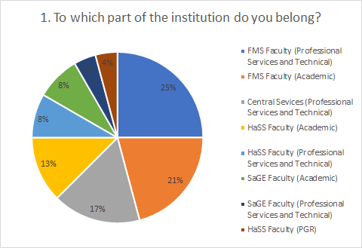
The results from this question show that the majority of respondents were from Professional Services and Technical job families (13 responses, 54.17%) and that all FMS Faculty job families constitute the largest share of responses (11 responses, 46%).

Within Professional Services and Technical job families, the survey received the most responses from FMS Faculty members (6 responses), followed by Central Services (4 responses), HaSS faculty (2 responses), and SaGE faculty (1 response).

What activity organised this year by NU Women did you most value? (Writing Groups, Workshops, Blog Posts, Annual Lecture, Newsletter, Zine, Films, etc, etc).
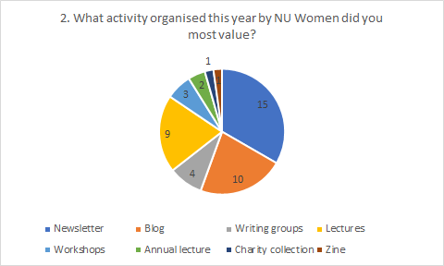

Participants were able to name three activities that they most valued. Members placed high value on being able to engage with NU Women online during this year.

The bi-monthly newsletter distributed to the Network was most valued (15 respondents), and then the blog, with some respondents noting that they appreciated being able to access recordings of lectures through the blog.

What do you think NU Women could do more effectively next year? What activity or action should NU Women add to its programme for next year?

The responses to this question focussed mainly on events that respondents would like to see running in the next year. Some expressed hope that in-person events might resume but there was also some suggestion that the online events ought to be more interactive/ workshop based. Some explicitly stated they were happy with the work the network is currently doing.

Sample Responses
- ‘​​Networking/career oriented events. Maybe this is more for when things get back to normal, but something like mixer events so we can get to know each other, or panels with women from specific career paths to talk about their experiences and how they got started would be really helpful’
- ‘online workshops (zoom incl. breakout rooms)’
- ‘I'm happy with what is currently provided. I can only attend some. The good thing is that I can catch up afterwards, as sessions have been recorded. That makes a big difference.’
- ‘It will be nice if we can get some face to face events running (Covid dependant). It would be good to have an NU Women take on the revised promotions form/criteria, and maybe some mentoring for colleagues looking for promotion (to reader/prof, but that's just my perspective, other may be looking at this for other levels).’
- ​​’With the other networks, look at inclusive research culture?’
- ‘Career conversations - not really more effectively - not sure if you did any this year - but events I have enjoyed in the past and would like to see more of.’

Any Other Comments
- ‘Following the pandemic, having a group for women at the University will be more important than ever and I'm so glad that you've kept up momentum even when things have been difficult.’
- ‘Accessing anything has been difficult this year due to circumstances and home school/ increased workload’

