The PhD: Surviving and Thriving
0.
I actually found it surprisingly difficult to sit down and begin putting together some thoughts about my PhD experience. I think part of the problem is that looking back, it doesn’t feel like clearly definable journey, something with a definite start, end and separable periods along the way, and it is certainly not something that now, having passed my Viva and made my final submission, I feel that I can look back on and give a concise summary account. Of course, there are those more tangible moments that we can pin the story of our PhD’s on: project approval, the APR, ethical approval, fieldwork, writing up, submission and the Viva. But the PhD is much more than this series of stepping stones.
Having said this, however, I think the metaphor of stepping stones is perhaps a useful way to begin to think about the PhD journey. If pinpoints like project approval, the APR, or, further down the line, the completion of a certain chapter and even the Viva, are like stepping stones through a river, then ‘the PhD experience’ is something more like the water that rushes between these points; sometimes the water is clear, sometimes it’s murky; sometimes it’s calm and cooling, sometimes scary and seemingly out of control; it is something that often leaves us feeling out of our depth, struggling to keep our heads above the water, but also something in which we cast ourselves adrift and can be led to new discoveries, both academic and personal.
So what I want to share today are some of my experiences of wading through a PhD, some of the excitement and sense of achieve that comes with each step, some tips for standing up against the tide and some experiences of losing my footing, getting caught in whirlpools, but eventually, with the help of others, pulling myself out again. I hope that there is something in what I have to share that everyone can relate to, but I think it is important to start off by saying that just like if wading through a river no two people can step into the same patch of water, there is no singular or standard ‘PhD experience’.
1.
This brings me to tip number one: everyone’s experience of a PhD is different; what works for one person might not work for another and we all work at different paces and intensities. While it’s sometimes tempting to compare ourselves to others as a way to try and gauge our progress, and we might long a universal secret to success, there is a limit to how useful such comparison or catch-all advice can be. When I think about my PhD cohort, each of us had very different experiences; we struggled with different aspects of the journey and excelled at different stages. Although we all helped each other along the way, each of us had to find a pace and style that worked for us. On the one hand, this might be liberating and hopefully it’s somewhat reassuring. It means that we shouldn’t hold ourselves to external definitions of ‘success’ and ‘progress’ and that we should allow ourselves time to work through things when we need. On the other hand, it also means that the PhD can leave us feeling lost, without guidelines for how to proceed and no well-trodden path to follow.

2.
One of the most salient features of my PhD were the constant shifts in confidence. Over the course of my PhD, across the different aspects of my thesis and even over the course of a single day I often went from feeling like I knew exactly what I was doing and that what I was writing was insightful to feeling that I was completely lost and that everything I wrote was pointless.
I think one of the most important things to try and do along the PhD journey, but also one of the most difficult, is to maintain confidence in the value and quality of our work and our ability to complete it. This is important not only for our own happiness and stability, but with confidence comes excitement and motivation, and the whole process of doing the PhD become easier.
For me, the first year of my PhD was the period at which I felt most confident and clear. I had just finished my masters and received funding to continue the research through a PhD. I had a research proposal that succinctly outlined what was to come over the next 4 years, making it sound straight forward and if not easy, at least achievable.
The first major blow to my confidence came with fieldwork, when all my careful planning and meticulous reading came up against the reality of my participants’ complex lives and the fact that their concerns didn’t align with what I expected that my research would be about. For the first few month of my fieldwork, I had so little confidence in what I was doing that I was scared to even think about my research, I was terrified of trying to face the question ‘what is my research actually about?’ and I even drafted an email to my supervisors telling them that I wanted to change my project entirely. Luckily that email never became more than a draft.
The second major challenge to my confidence came after finishing three data chapters, when I was once again faced with the painful question of what my research was really about. It might sound surprising, but after writing the three main chapters of my thesis, I was still unsure of what my thesis was about; I was unable to summaries it and, again, terrified of facing up to these questions. This became a block to progress, especially as I was moving on to the literature review and methodology chapters, which were supposed to say something about the research as a whole.
These are quite specific examples form my own experience, but I think a loss of confidence is something that many of us experience at various points for various reasons. If there is one thing that I wish I had been told at the start of my PhD, it is that losing confidence in your research and in your ability to complete it is probably an inevitable, completely normal and in fact very useful part of the research process and, while it might feel like running up against a brick wall, it might also be an opportunity to think about new directions or to open up new ways of thinking.
For me, the most important way of getting out of these dips in confidence was to think and to write about where these feelings were coming from and to address this as part of the research process itself. Rather than taking these feeling as something external to the research that was getting in the ways of its progress, I eventually came to see feelings of uncertainty, confusion and a lack of confidence as inherent to my research.
So, in those first few months of my fieldwork, when I was struggling with the disconnect between what I had thought my PhD was going to be about and what my participants really cared about, I found a way to work through this by turning it into an opportunity to think reflexively about some of the fundamental concepts that I was working with. In the end, this led to a critical questioning of concepts like identity, sexuality, and space and this questioning become central to my thesis. Similarly, when I was faced with the problem of the overall coherency of my thesis after finishing three data chapters, I managed to regain confidence by thinking critically about coherency itself; this brought to the fore issues of narrative and processes of sense making and it became clear that what I was exploring was in fact a range of ways in which people make sense of their own lives and manage the pleasures and pains of living in contexts of uncertainty and incoherence.
Now, these are specific solutions to specific problems, but I think there is something general here that might be useful to think about when faced with uncertainties and a break in confidence. Tip number two then: losing confidence and losing your way is completely normal and part of the process. Thinking carefully about where uncertainties are coming from may turn them into opportunities for progress of a different kind.
3.
There is something else in this that I think might be a useful piece of advice. I mentioned that my strategy for overcoming losses of confidence and subsequent writers block was to turn to reflexive forms of thinking and writing, and I definitely think that connecting our own uncertainties to the research process is something that is generally useful. However, this strategy also played on my own specific interests in reflexivity and methodology. It was a strategy that appealed to my own passions, a kind of thinking and writing that I feel comfortable with and something that I feel I’m fairly good at. I know that this kind of thinking and writing is not something that everyone finds enjoyable or useful, so this might not work for everyone.
At the same time, however, it might be useful to recognise the importance of playing to our particular strengths and passions, especially at times when we begin to doubt ourselves. This will likely be different for everyone, for me it was reflexive, critical methodological thinking and writing, for others it may be a different aspect of the research process or a different style of thinking and writing.
Tip number three, then, is to know your strengths and passions and use these to your advantage, especially when you feel stuck or lose confidence. Of course, an integral part of the PhD is being pushed out of comfortable ways of thinking and developing new skills, but knowing our individual strengths and returning to these when we need to can be an important way of regaining confidence, overcoming writers block and re-energising ourselves.

4.
I think that one of the things that makes us so susceptible to losing confidence and feeling lost along the PhD journey is the fact that it can be a lonely process; we devote ourselves to our individual projects and the thesis can sometimes feel like a rabbit hole that we’ve fallen into and can’t find our way out of again. Added to this is the pressure of knowing that responsibility for the quality of our research rest largely on our individual shoulders. We can often end up feeling alone and overwhelmed. This was certainly something that I felt at various points, especially during writing up, when the thesis begins to take shape but can feel like a hole that you’re digging deeper and deeper, and I know that loneliness was something that others in my PhD cohort struggled with. To some extent, this is unavoidable; we are the sole authors of our theses and no one else is as caught up in the minute details of our research as we are. But there are ways of coping with and reducing the feeling of isolation.
For me, one of the most important things that got me through my PhD and made me feel less alone was working in a shared office and having people around me who were going through the same issues. For all the trials and tribulations of doing a PhD, I still found it a massively enjoyable journey and I owe a lot of that to the people that I shared an office with. Even though we all worked on very different projects, having others around me with whom I could share my worries and talk through ideas made it so much easier to articulate and face up to a particular problem. Often just having someone to try and explain a problem to and the process of speaking out loud, was enough to put things in perspective, to gain clarity, and find a way to move on. Also, listening to other people’s worries reminds you that you are not alone and that it is normal to struggle. Tip number four, then, is to spend time in your shared office, share your concerns and share your PhD journey with those around you.
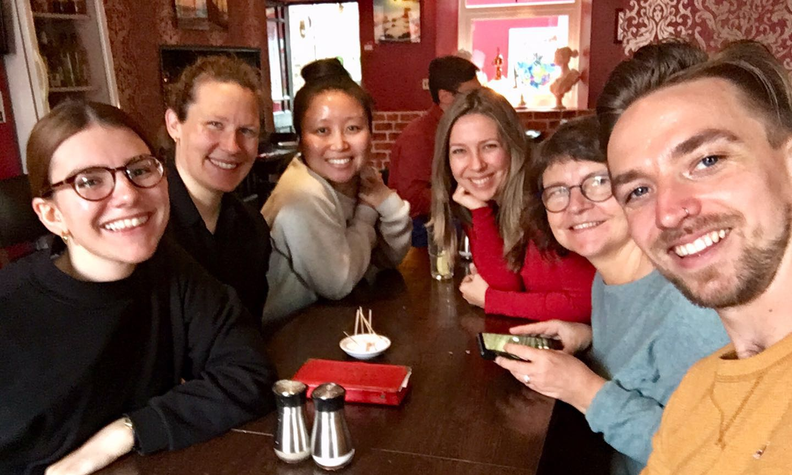
5.
In addition to feeling a sense of belonging to my office, something that has been very important for me is a sense of belonging to the department. This certainly helped me to feel less isolated and to feel that I haven’t just been working on my own research but have been part of a research community and contributing to the research culture in Sociology. This has also been the most important way in which I’ve gone from coming into the PhD feeling like a student, to finishing my PhD feeling like an academic. Tip number five, then: get involved with activities in the department and think of yourself as part of the research community.
Events like the Celebrating PGR Sociology workshop, for which I was invited to put together and present these thoughts on getting through a PhD, are a really important way of reminding ourselves that our PhD’s are a shared experience and, for me, attending the seminar series, taking an active role in the research clusters and generally participating in the full range of activities in the department has meant that my PhD was more than my own independent research project; it was also a matter of belonging and contributing to an academic community.
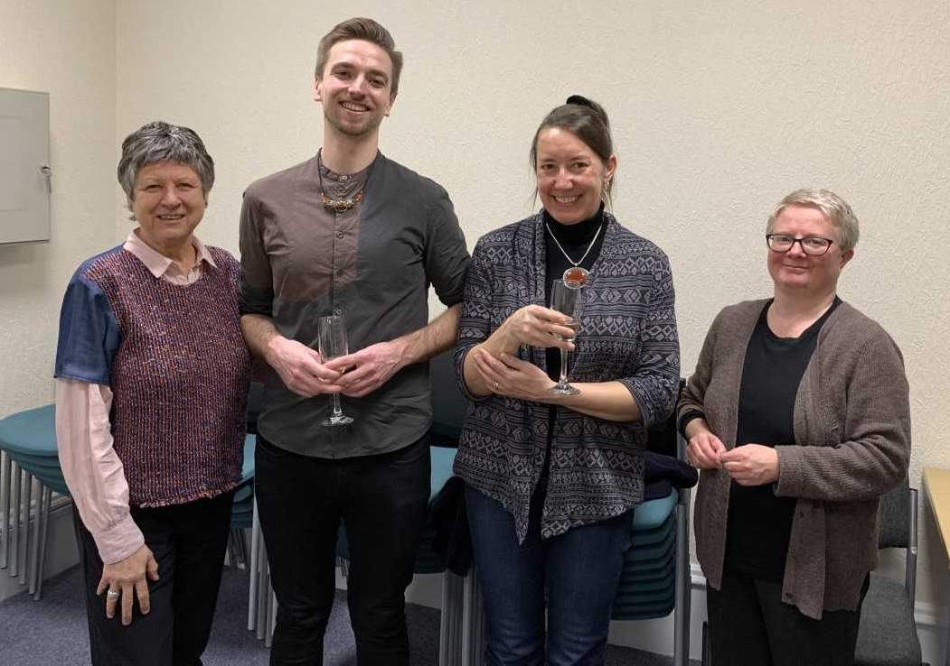
6.
Finally, on this theme of managing feelings of isolation on the PhD journey, one of the key sources of support is, of course, our supervisors. Besides ourselves, the only other people who are deeply invested in our research and have an understanding of the specific problems that we might be facing are our supervisors. For me, my supervisors have been an incredible source of guidance and support.
Tip number six, then, is to make use of your supervisors. I mentioned earlier that one of the ways that I dealt with some of the problems I faced in my PhD was to write about them, this was useful not only a way of clarifying problems for myself but it also meant that I had a way of sharing problems with my supervisors and something tangible to use to thinks about ways of moving forward. Some of the most useful documents that I returned to when writing my methodology and some of the key turning points in my research emerged from crisis emails written to my supervisors. As well as saying ‘make use of your supervisors’, I guess I should add the caveat that making the most of supervision and turning to supervisors for help requires preparation on our part in terms of identifying problems, and being open and honest so that there is something tangible to work through with your supervisors.
7.
So far I’ve mentioned ways of managing some of the difficulties that can arise in the PhD by focusing more intensely on the research process and by being in the office and engaging in activities in the department. However, another problem that can arise in the PhD is the feeling that it is taking over your life; you wake up thinking about your research; you spend all day working on your research; you go to bed thinking about your research and, on occasion, you wake up in a cold sweat in the middle of the night having dreamt about your research. Sometimes, the way that the PhD pervades every moment of your life is unavoidable, particularly during intense periods of writing, and the only way to cope with this is to constantly carry a pen and note pad with you so that when an idea comes to you, you can note it down to think about later. However, I think it is also important to try and find ways to take time out from the PhD and to set some time aside to work on other things.
For most of my PhD, I tried to keep a degree of separation between work and home by treating my PhD like a nine to five job, coming into the office in the morning, having a list of objectives for the day and going home once they were completed, or else adding them a list of objectives for the following day.It is much easier to maintain motivation and excitement about your research, and avoid exhaustion, when you feel that it is something you are engaged in for a defined period of time and working through in small steps, rather than something that is constantly weighing on your mind.
It is worth mentioning, for those who find to-do list useful, that it is better to ere on the side of small and achieve able tasks, like reading a certain article, writing 300 words and sending a particular email, rather than major tasks like finishing a chapter. There are few things as satisfying along the PhD journey as crossing off everything on your to do list, closing down your computer and going home at 5 o’clock with the smug confidence that you did everything you intended to do for the day, and it is much easier to achieve this when working with small tasks.
Tip number seven, then, try to find a work routine and give yourself time and space to switch off. This doesn’t necessarily mean being in the office nine to five, Monday to Friday and it may be a matter of finding times and spaces that work for you. But it can be very helpful to aim for a routine and structured approach to work, especially during the writing up stages when we are most susceptible to feeling overwhelmed.
8.
On a similar note, allowing time to get involved in activities that may have a connection to your PhD but don’t involve sitting down and writing can be a good way to maintain momentum and feel that you are being productive, while also taking a break from staring blankly at a word document wishing that words would appear.
There are all sorts of activities that can play this role. For me, teaching, in particular, has been an opportunity to take a break from writing while still doing something that was part of my PhD experience in a broader sense. Also, last year, I took part in a programme called Performing Research, where I worked with a choreographer to turn themes from one of my data chapters into a dance performance; this allowed me to push on with writing the chapter with renewed interest and passion.
Tip number eight, then, is to diversify your PhD experience, break up the monotony of writing up with activities that are exciting but still feel productive. I know that for others such activities have included organising events and conferences, making and showing films, writing short pieces for non-academic audiences, and engaging in volunteer work connected their research.
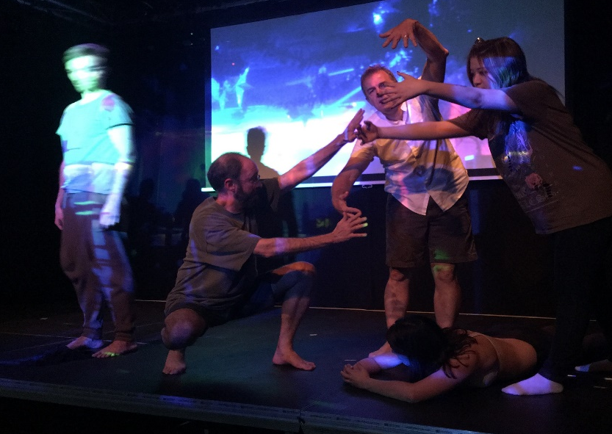
9.
Now, advice on planning, routine and making time for other activities is hopefully useful, and these are things that I think it is good to aim for; however, I say ‘aim for’ because I know that, in reality, the best laid plans don’t always come to fruition and I’ve certainly sent my fair share of emails to my supervisors at 4am submitting a draft chapter with apologies that it’s a week late and still only half finished.
This brings me to tip number nine: sometimes you just have to power through and commit to getting something finished. In spite of everything I just said about small achievable tasks and a comfortable work routine, there may still be times when you have to commit to finishing something which may mean working through the night or typing out a stream of consciousness until everything you want to say is down on paper.
It can be hard to push yourself in this way, especially in the early stages of writing up when your submission deadline seems far enough away that it won’t matter if you spend another week working on a chapter. But in my experience, a week can easily turn into two weeks, then a month, and so on. Sometimes, it is worth pushing yourself to hit a deadline and moving on to something else, even if this means producing work that you are not entirely satisfied with. It seems that everyone has that one chapter that they find it almost impossible to finish, it keeps getting longer and longer without an end in sight, or it’s on its 10th redraft without any particular sense of improvement. In these instances, we might have to learn to live with dissatisfaction and move on.
10.
So, my final tip: your thesis doesn’t have to be perfect, it just needs to make sense and be finished. This is of course easier to say than to put into practice and I know that the fact that we have chosen to do PhDs means that we are largely the sort of people who obsess over details and nuances, but I always found it helpful to remind myself that the PhD is our first piece of independent, large-scale research; it is not a magnum opus; it is only the beginning of our research careers and is bound to have its faults and things we wish we had more time and space to work on. A thesis has its limits and sometimes a well-used footnote that begrudgingly acknowledges these limits and gives you license to move on might just save you months of anguish and frustration.
11.
So, those were my ten tip for surviving and mostly thriving during your PhD, these are things that I wish I could have told myself at the start of my journey, things I learned along the way and things that worked for me. To re-cap:
- Everyone’s experience of the PhD journey is different, there is no universal standard for success and progress.
- Losing confidence and losing your way is completely normal and part of the process. Try to approach problems as opportunities for a different kind of progress.
- Know your strengths and passions and use these to your advantage when you are struggling.
- Make use of your shared office, share your concerns, and share your PhD journey with those around you.
- Get involved in the department and think of yourself as part of the research community.
- Use your supervisors, but also help them to help you by reflecting on problems you are facing.
- Try to find a work routine and give yourself time and space to switch off
- Diversify your PhD experience, break up the monotony of writing with activities that are exciting and productive.
Having said this,
9. Sometimes you just have to power through and commit to getting something finished
And finally,
10. Your thesis doesn’t have to be perfect, dissatisfaction is also part of the process.
Of all of these, perhaps the first and the fourth points are most important, at least they were for me. The PhD is very much an individual journey and we can’t always judge our own success and progress through comparison to others, but this doesn’t mean that we are in it alone. It is a journey that we make alongside others and, for me, it was the support of friends and colleagues that carried me through my PhD and made it an enjoyable journey.

